Success Criteria:
- I can talk and listen in a range of different situations.
- When I speak, I usually think about my audience and make sure that what I'm saying is appropriate.
- I can develop my ideas when I'm speaking.
- I listen carefully in discussions and sometimes ask questions.
I sometimes use standard English vocabulary and grammar.
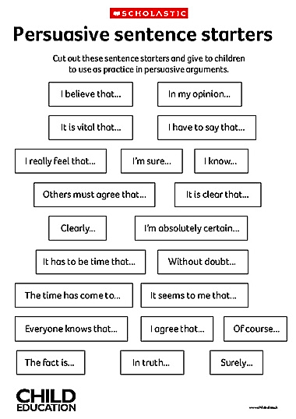
- Listen to others and think about what they are saying
- Speak clearly and confidently
- Think about what you want to say and how it will connect with other people’s points
- Help your fellow classmates if they forget their point or if they are struggling. Avoid radio silence where possible.
Success Criteria:
- I can talk and listen in a range of different situations.
- When I speak, I usually think about my audience and make sure that what I'm saying is appropriate.
- I can develop my ideas when I'm speaking.
- I listen carefully in discussions and sometimes ask questions.
I sometimes use standard English vocabulary and grammar.
- Listen to others and think about what they are saying
- Speak clearly and confidently
- Think about what you want to say and how it will connect with other people’s points
- Help your fellow classmates if they forget their point or if they are struggling. Avoid radio silence where possible.
Success Criteria:
- I can talk and listen in a range of different situations.
- When I speak, I usually think about my audience and make sure that what I'm saying is appropriate.
- I can develop my ideas when I'm speaking.
- I listen carefully in discussions and sometimes ask questions.
I sometimes use standard English vocabulary and grammar.
- Listen to others and think about what they are saying
- Speak clearly and confidently
- Think about what you want to say and how it will connect with other people’s points
- Help your fellow classmates if they forget their point or if they are struggling. Avoid radio silence where possible.

