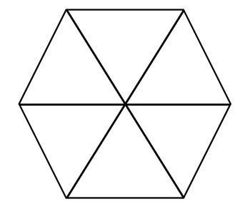
What is the title of the text?

__________________________________________________________________________________________________________________________________________
Who is the author of the text?

______________________________________________

Do you know anything about the text or topic already?
______________________________________________

______________________________________________

______________________________________________

What type of text is it?
(Circle or highlight the correct one)

Is it prose? a fictional story created from the writer’s influences, experiences or their imagination.

Is it non-fiction? non-fiction texts are those that deal with facts, opinions and the real world. Types of non-fiction writing include newspapers, adverts, brochures, reference books and biographies.

Is it poetry? language chosen and arranged for its meaning, sound, and rhythm. It is typically written in verse.

Who? What?
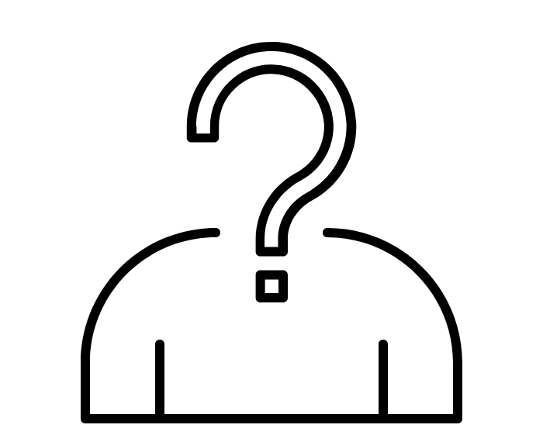
Summarising
Briefly explain what the text is about: (you can use bullet points).
_______________________________________________________________________________________________________________________________________________________________________________________________________________________________________________________________________________________________________________________________________________________________________________________________________________________________________
_______________________________________________
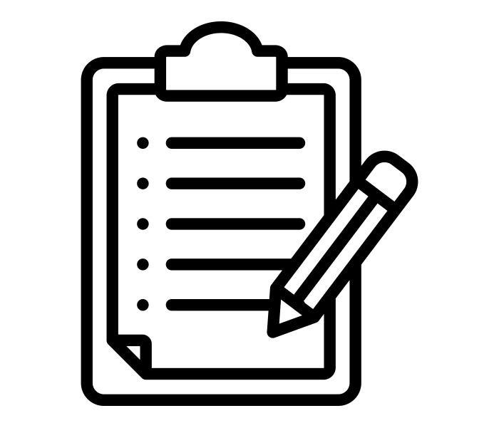

Reading difficulty level:
1 2 3 4 5

Easy
Too easy
Very difficult
Challenging
Just right
What type of text do you think this is? (Highlight above)

What is the text called and who wrote it? What did you know already?
In your own words, summarise what the text about.

Reading
Warm-Up
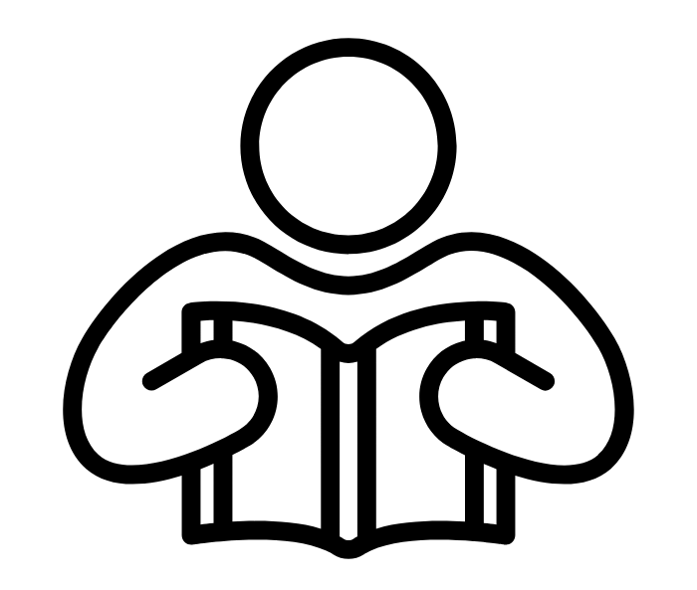
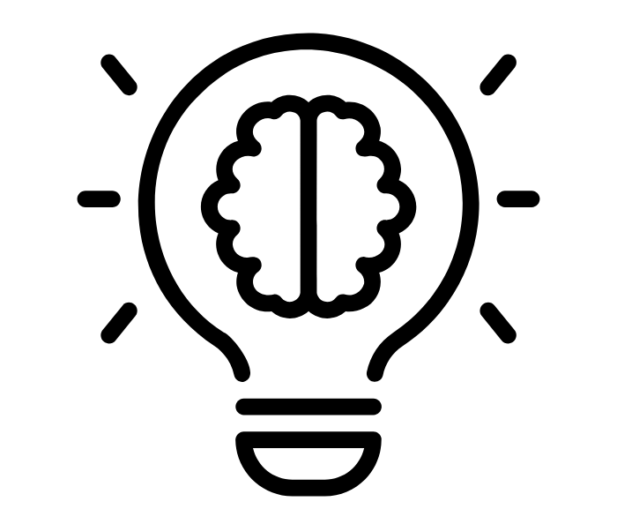
Reflections
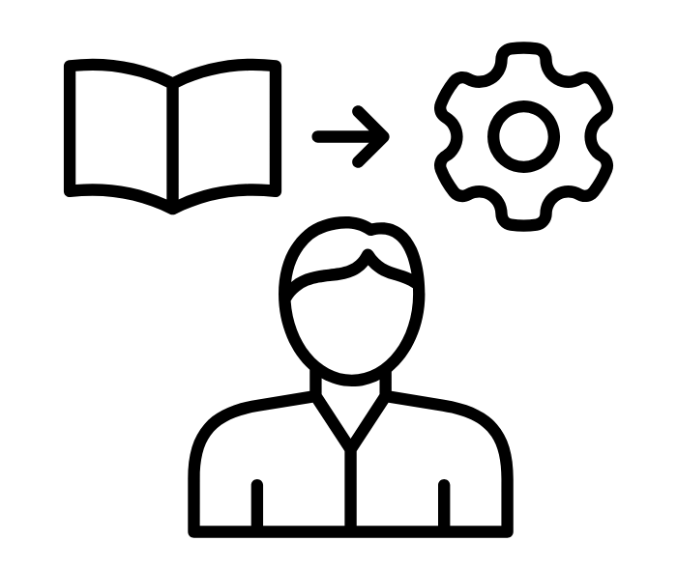
What have YOU learned from reading the text?
Share with
your partner.

What do YOU think are the most important or interesting sentences in
the text?
- _____________________________________________________________________________________________________________________________________________________________________________________________________________________________________________________________________________________________________________
- ____________________________________________________________________________________________________________________________________________________________________________________________________________________________________________________________________________________________________________________________________________________________________________________________________________________

Everyone will have different answers. It is about what YOU think.
New or interesting words I have learned
OR words I do not understand yet:

word | definition

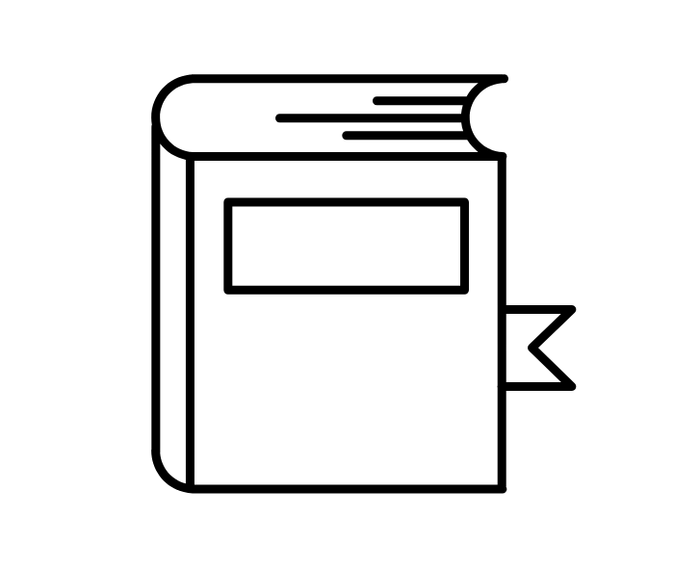
Vocabulary
What new information have you learned?
What have you learned about the writer?
What lessons or advice have you gained from the text?
1_________________________________________________________________________________________________________________________________________2_________________________________________________________________________________________________________________________________________3________________________________________________________________________________________________________________________________________________________

Selecting
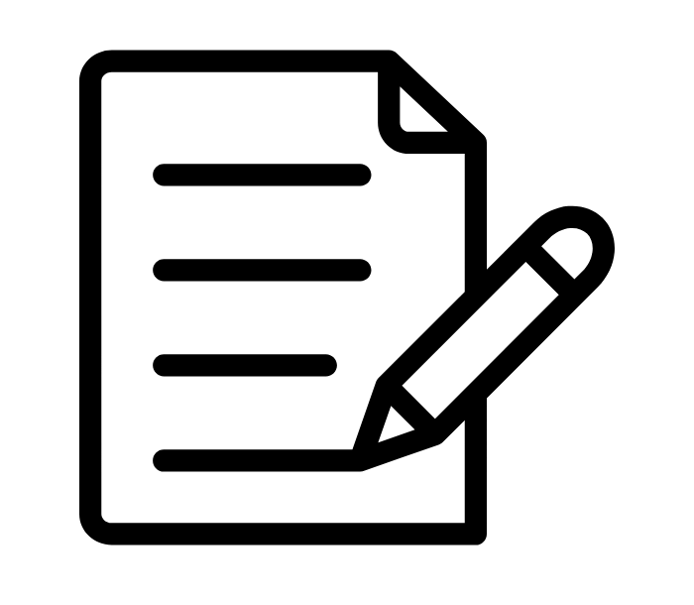
Make a list of any new words you have read or that you do not understand.

